Dental Clinic management system

**Developed By:**

**Nirav Patel : 205170686029**

**Simarpreet Saini : 205170686012**

**Darshan Prajapati : 205170686018**

**Group No : MCM**

**Under the Guidance of :**

**Prof. Shivangi Kothari**

**Submitted To :**

**L.J. Institute of Computer Application**



**L.J. INSTITUTE OF ENGINEERING & TECHNOLOGY**

Near Nagdev Kalyan Mandir, Near Sarkhej Cross Roads,

Sarkhej-Gandhinagar Highway  Ahmedabad - 382210  
Ph. No. : 079 29296364



***CERTIFICATE***

**Enrollment No**: **205170686029**

This is to certify that Mr. / Ms. **Nirav Dasharathbhai Patel** studying in Integrated Master of Computer Applications, Semester VII, Roll No **27** has satisfactorily completed his/her Project Titled **Dental Clinic Management System**  under the supervision of **Prof. Shivangi Kothari**

**Internal Guide Name :** **Signature**

Prof. Shivangi Kothari

**Date of Submission: 27/4/2023**

**L.J. INSTITUTE OF ENGINEERING & TECHNOLOGY**

Near Nagdev Kalyan Mandir, Near Sarkhej Cross Roads,

Sarkhej-Gandhinagar Highway  Ahmedabad - 382210  
Ph. No. : 079 29296364



***CERTIFICATE***

**Enrollment No**: 205170686012

This is to certify that Mr. / Ms. **Simarpreet Saini** studying in Integrated Master of Computer Applications, Semester VII, Roll No **45** has satisfactorily completed his/her Project Titled **Dental Clinic Management System**  under the supervision of **Prof. Shivangi Kothari**

**Internal Guide Name :** **Signature**

Prof. Shivangi Kothari

**Date of Submission: 27/4/2023**

**L.J. INSTITUTE OF ENGINEERING & TECHNOLOGY**

Near Nagdev Kalyan Mandir, Near Sarkhej Cross Roads,

Sarkhej-Gandhinagar Highway  Ahmedabad - 382210  
Ph. No. : 079 29296364



***CERTIFICATE***

**Enrollment No**: 205170686018

This is to certify that Mr. / Ms. **Darshan Prajapati** studying in Integrated Master of Computer Applications, Semester VII, Roll No **39** has satisfactorily completed his/her Project Titled **Dental Clinic Management System**  under the supervision of **Prof. Shivangi Kothari**

**Internal Guide Name :** **Signature**

Prof. Shivangi Kothari

**Date of Submission: 27/4/2023**

**TABLE OF CONTENTS**

Introduction

1. Existing System

2. Need for the New System

3. Objective of the New System

4. Problem Definition

5. Core Components

6. Project Profile

7. Assumptions and Constraints

8. Advantages and Limitations of the Proposed System

9. Proposed Time Line Chart

• Requirement Determination and Analysis

1. Requirement Determination

2. Targeted Users

3. Requirement Specification

• System Design

1. Use Case Diagram

2. Class Diagram

3. Activity Diagram

4. Data Dictionary

5. Sequence Diagram

6. User Interface Design

7. Report Design

• Testing

1. Testing Method
2. Test Cases

• Proposed Enhancement

1 Proposed Enhancement

• Conclusion

1 Conclusion

• Bibliography

1 Bibliography

INTRODUCTION

Dental Clinics, Dental department or other specialty department in a general hospital can use this software. Though this software was designed primarily with the inputs from dental Clinics, it could be adoptable in other specialty hospitals also, with some little changes in the medical terms, database etc.

DCMS software has been developed to provide comprehensive software solution for the clinics. But there are clinics that cannot afford to run such comprehensive system or may not be required due to the volume of work handled. Still to encourage such clinics to use computers for generating useful information to run the organization efficiently, we provide the following Software from which one can choose according to their requirement.

It is a system which will help dentist to keep track patient dental problems, from time to time. This system allow dentist to help patient to improve their awareness and take care about their oral health. The data regarding the patient dental information will help the patient in order to apply for the next treatment and also to be use for the future.

DCMS can analysis the data that had been captured and come out with the analysis report to summarize the dental score for each patient. The reports able to summarize the patient dental healthcare performance from time to time according to the treatment made. Other than help the patient to upgrade their awareness regarding the oral health, these reports will also give benefits to patients as they can view their dental health performance.

information to run the organization efficiently, we provide the following Software from which one can choose according to their requirement.

It is a system which will help dentist to keep track patient dental problems, from time to time. This system allow dentist to help patient to improve their awareness and take care about their oral health. The data regarding the patient dental information will help the patient in order to apply for the next treatment and also to be use for the future.

DCMS can analysis the data that had been captured and come out with the analysis report to summarize the dental score for each patient. The reports able to summarize the patient dental healthcare performance from time to time according to the treatment made. Other than help the patient to upgrade their awareness regarding the oral health, these reports will also give benefits to patients as they can view their dental health performance.

*Existing System*

## Existing system refers to the system that is being followed till now. Presently all the clinics functionalities are done manually. That is if a patient want to consult a doctor he can visit their till his chance called. This is make the person very difficult. An Appointment are distributed directly. The main disadvantage is time consuming. Limitation of existing system is if sum one patient loses his receipt, difficulties to find out patient has assign tickets. To defect this limitation we do computer system.

The current system works as the following:

* In the old system, the user was maintaining the records like number of books, CD’s, DVD’s and subscribers., Fees Detail and bill (Receipt) in the paper sheets.
* Hence it was very difficult for him to keep track which Customer has been taken which cd or dvd, what is the Bill no, etc.
* The manpower required for this kind of transaction and maintenance of data is higher than the actual requirement.

LIMITATIONS OF EXISTING SYSTEM( Need for the New System)

No system can be referred as complete system in all aspects. In spite of successful executions of testing plan .The problem arises, when the system is input in the real working environment, the problem that will arise cannot be visualized and their solution cannot be predetermined to be rectified.

* The designed product is stand alone system.
* It works on current basis.
* On-line booking, transaction etc are not possible.
* Lack of security of data.
* Time consuming.
* Consumes large volume of paper work.
* Manual work
* No direct role for the higher officials.
* To avoid all these limitations and make the system working more accurately it needs to be computerized.

*PROBLEM DEFINATION*

Comprehensive Dental care services that deliver effective, safe, high-quality interventions to those that need them, when and where needed, with minimum waste of resources, and with continuity of care across levels of care, settings, and providers. Our software has the facility to give a unique id for every patient and stores the details of every patient and the Doctor automatically.

*Core Components*

Admin :-

Login

Register

Manage Dentist

Manage Patients

Manage Appointments

Manage Treatments

Manage Payments

Manage Reports

**Dentists :-**

Login

Manage Appointments

Manage Treatments

Manage Payments

**Patients :-**

Login

Register

Manage Appointments

Manage Treatments

Manage Payments

*Project Profile*

|  |  |
| --- | --- |
| PROJECT TITLE | Dental Clinic Management System |
| Objectives - | **OBJECTIVES**   1. System manages to save all the patient record accurately and computerized. 2. System should able to avoid the data redundancy of patient dental information. 3. System should manage to check the available date and time to make appointment between dentist and patient. 4. System able to display patient dental history and treatment that had been done. 5. Generate report of patient dental condition according to the treatment session and many other criteria 6. Generate valuable report regarding number of patient visit for treatment at the clinic. |
| Front End - | Asp.net , c# |
| Back End - | MySQL 7.4.12 |
| Documentation Tools - | Microsoft word |
| Developed By - | 1. Nirav Patel (ICA 27) 2. Simarpreet Saini (ICA 45) 3. Darshan Prajapati (ICA 39) |
| Internal Guide - | **Prof. Shivangi Kothari** |
| Submitted to - | **Prof. Shivangi Kothari** |
|  |  |

*Assumptions and Constraints*

Size - The Size of the clinical database System has a very huge database that makes the system heavy and this increases the access time of the database.

Time-The time given to complete the project is only one semester which is very limited for completion of such a big project.

Expenses -The process of completing the whole project will require some money which will cater for Internet access and purchase of a domain to test the system

Clinical management System will only benefit those who know about the internet, this means the computer illiterate will not be able to use it.

No money was allocated for the project and this may to some extend limit the product

*Advantages of the proposed System*

1. All Registrations can be completed automatically as you enter data.
2. Data can be saved automatically soon after it is entered so that the risk of data being lost is minimized.
3. Sorting and storing documents and other information like searching is much easier.
4. Searching and retrieving data is much easier.
5. Validation rules can be used in order to guarantee better verification
6. Addition of new patients, modification of appointment, keeping the patient’s treatment history will be simple

**PROPOSED TIME LINE CHART**

|  |  |  |  |
| --- | --- | --- | --- |
| **Sr. No** | **Activity** | **Description** | **Period (Until)** |
| **1.** | Requirement Analysis | Collected requirement from our guide  Analyse gathered information  Determine the scope of the system |  |
|  | Milestone: Requirement Analysis completed |  | 1st Month 2nd week |
| **2.** | Planning and Risk Analysis | Identify technical risks  Analyse data for possible risks |  |
|  | Milestone: Planning completed |  | 1st Month 4th week |
| **3.** | Designing | Interface design  Database design  Web form design for modules |  |
|  | Milestone: Designing completed |  | 2nd Month 1st week |
| **4.** | Coding | Implement logic  Implement database connectivity  Integrate modules |  |
|  | Milestone: Coding completed |  | 3rd Month 1st week |
|  |  |  |  |
| **5.** | Test & Implementation | Validate inputs  Check accuracy |  |
|  | Milestone: Testing completed |  | 3rd Month 3rd week |

## Software Requirements Specification

The software requirements specification is created when the analysis activity is completed. The function and performance assigned to the software as part of system engineering are refined by providing a complete description of the information, a detailed description of the function and behavior, an indication of performance requirements and design constraints, appropriate validation criteria, and other data. relevant to the requirement. The proposed system has the following criteria:

* The system must store information about the new entry of the dental clinic.
* The system is intended to help in-house employees track doctors and find them through various consultations.
* The system must keep a record of quantity.
* The system must maintain the patient’s record.
* The system must update and delete the record.
* The system also requires a lookup field. It
* The system will also need a security system to prevent data.

Requirement Determination and Analysis

Requirement Determination

**Similar website study**

Here is a brief study of some of the similar websites for dental management systems:

1. Dentrix: Dentrix is a popular dental management software that offers a comprehensive suite of features, including appointment scheduling, patient records, billing and insurance management, and dental imaging. It is designed to improve the efficiency of dental practices and provide better patient care. Dentrix also offers a mobile app that enables dentists to access patient information from anywhere.

2. Open Dental: Open Dental is an open-source dental management software that provides features such as appointment scheduling, patient records, billing and insurance management, and dental imaging. It is a cost-effective solution that can be customized to meet the specific needs of dental practices. Open Dental also offers a range of add-on modules for additional functionality.

3. Eaglesoft: Eaglesoft is a dental management software that provides features such as patient records, appointment scheduling, billing and insurance management, and dental imaging. It is designed to streamline dental practice operations and provide better patient care. Eaglesoft also offers an online patient portal that enables patients to access their records and schedule appointments.

4. Curve Dental: Curve Dental is a cloud-based dental management software that provides features such as patient records, appointment scheduling, billing and insurance management, and dental imaging. It is designed to improve the efficiency of dental practices and provide better patient care. Curve Dental also offers a mobile app that enables dentists to access patient information from anywhere.

5. Practice-Web: Practice-Web is a dental management software that provides features such as appointment scheduling, patient records, billing and insurance management, and dental imaging. It is designed to help dental practices increase productivity and profitability. Practice-Web also offers an online patient portal that enables patients to access their records and schedule appointments.

These dental management software solutions offer similar features but differ in their pricing models, deployment methods, and customization capabilities. Dental practices should evaluate their specific needs and budget to determine which dental management software solution is the best fit for them.

**Targeted Users**

The targeted users for a dental management system website are primarily dental practitioners and their staff. This includes dentists, dental hygienists, dental assistants, and front desk staff who are responsible for managing the day-to-day operations of a dental practice.

In addition to dental practitioners and their staff, patients can also be considered targeted users of a dental management system website. Some dental management systems offer a patient portal where patients can access their dental records, view appointment schedules, and communicate with their dental providers. This enhances patient engagement and improves the overall patient experience.

Moreover, dental management system websites can also be targeted towards software vendors and resellers who provide dental management solutions to dental practices.

Overall, dental management system websites are designed to provide information about the features and benefits of the software solution to potential users, including dental practitioners, their staff, and patients. The website should also provide support resources, such as user manuals, FAQs, and customer support contact information, to help users get the most out of the dental management system.

* 1. **Requirement Specification**

**Hardware requirement**

**Client-side tools**

Processor: Intel i5 Pentium 4

Ram: 8gb

HardDisk: 512gb

**Server-side tools**

Processor: Intel i5 (2.4GHz) (minimum)

Ram: 8gb

HardDisk: 1TB (minimum)

**Software Requirement**

Operating System : Windows

Front-end: Visual Studio 2022

Back-end: My SQL

Database-Technology: My SQL

Functional Requirement :

1. Patient Management: The system should allow dentists to manage patient information such as personal details, medical history, treatment plans, and appointment schedules.

2. Treatment Planning and Management: The system should allow dentists to create and manage treatment plans for each patient, including procedures, materials, and costs. It should also provide tools for managing inventory and ordering supplies.

3. Dental Imaging: The system should allow dentists to capture, store, and view dental images such as X-rays, intraoral photos, and scans.

4. Billing and Payment Management: The system should provide features for billing and payment management, including insurance verification, claims submission, and payment processing.

5. Reporting and Analytics: The system should provide reporting and analytics features to help dentists track key performance indicators, monitor financial performance, and identify areas for improvement.

**Non-Functional Requirement**

1. Security: The system should be secure, with features such as user authentication, data encryption, and regular backups.

2. Reliability: The system should be reliable, with high availability, fault-tolerance, and disaster recovery features.

3. Scalability: The system should be scalable, able to handle a growing number of patients, dentists, and clinics.

4. Usability: The system should be user-friendly, with an intuitive user interface, easy navigation, and minimal training requirements.

1. Performance: The system should perform well, with fast response times, minimal downtime, and minimal resource usage.

**Function Details**

A dental management system website should provide detailed information about the features and functionalities of the software solution. Some of the functional details that could be included on a dental management system website are:

1. Appointment scheduling: The website should describe how the dental management system helps dental practices manage appointments efficiently, including features like automated reminders, appointment confirmations, and waitlist management.

2. Patient records management: The website should provide information on how the system helps dental practices manage patient records efficiently, including features like digital imaging, treatment plans, and medical histories.

3. Billing and insurance management: The website should explain how the system helps dental practices manage billing and insurance claims effectively, including features like electronic claims submission and payment processing.

4. Communication and collaboration: The website should describe how the system enables dental practices to communicate and collaborate more effectively, including features like secure messaging, patient portals, and referral management.

5. Reporting and analytics: The website should explain how the system helps dental practices track key performance indicators and generate reports that can inform business decisions, including features like financial reports, practice performance metrics, and patient feedback surveys.

6. Integration capabilities: The website should provide information on how the dental management system integrates with other software solutions commonly used in dental practices, such as electronic health record systems and practice management software.

7. Training and support: The website should describe the training and support resources available to users, including user manuals, FAQs, video tutorials, and customer support contact information.

Overall, the functional details provided on a dental management system website should be comprehensive, clear, and easy to understand, and should convey the value and benefits of the software solution to potential users.

**USE CASE DIAGRAM**

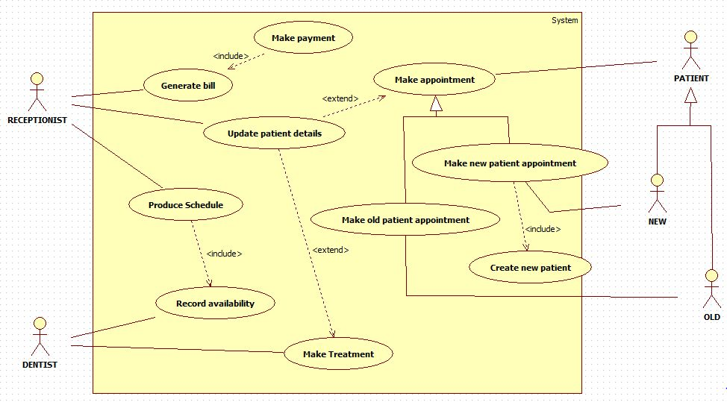

Class Diagram

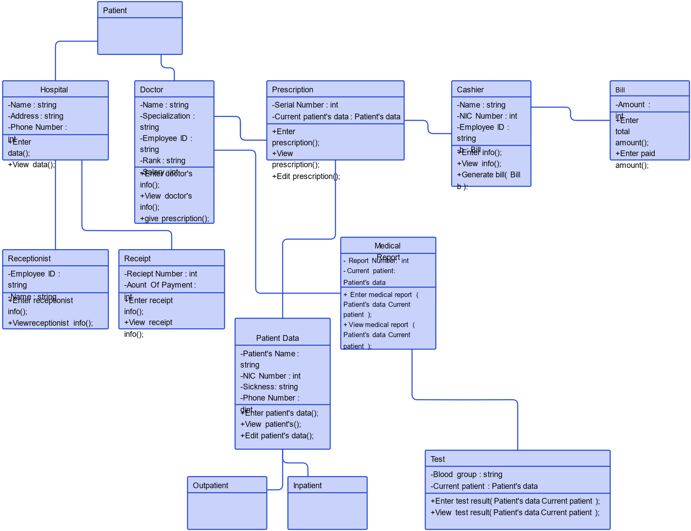

Sequence diagram

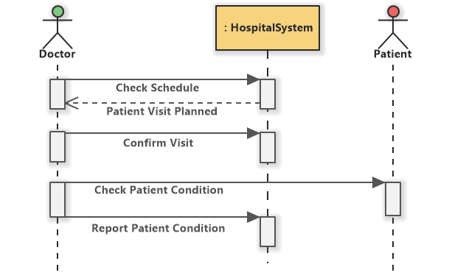

Activity diagram

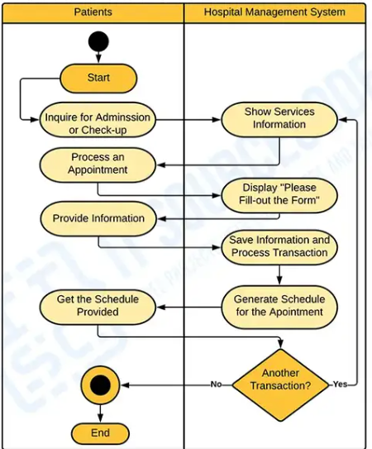

ACTIVITY DIAGRAM FOR TWO USER

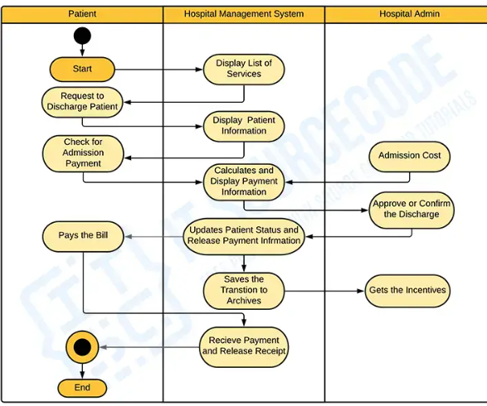

Data Dictionary

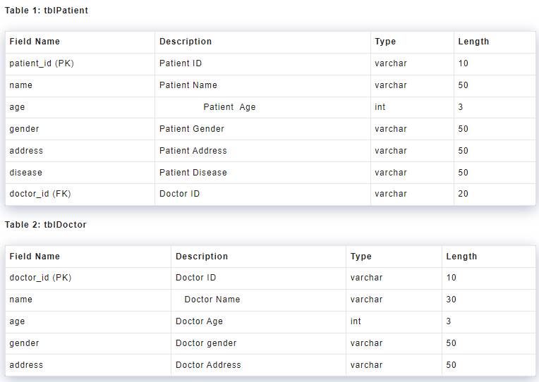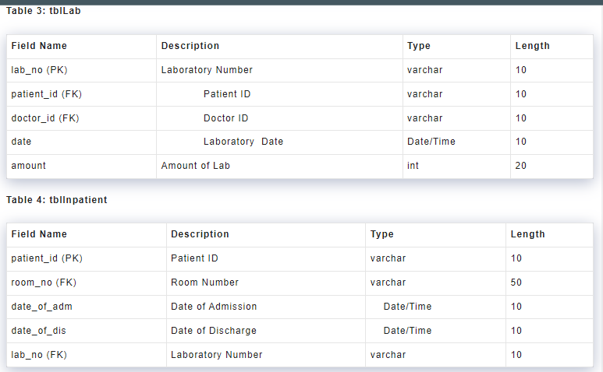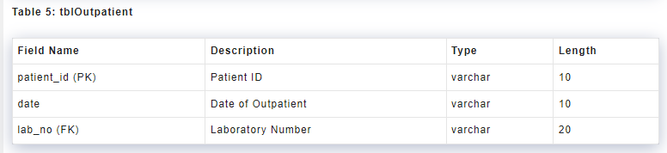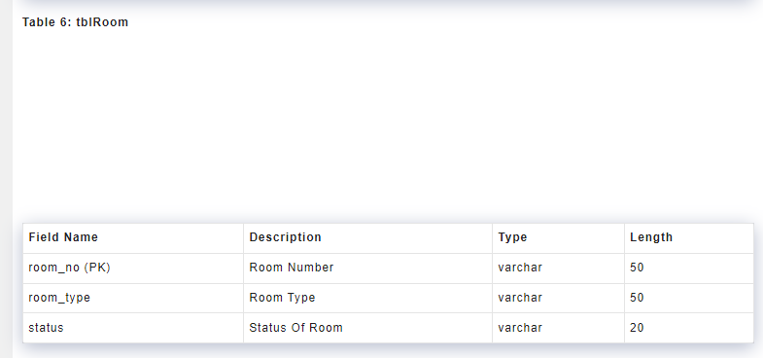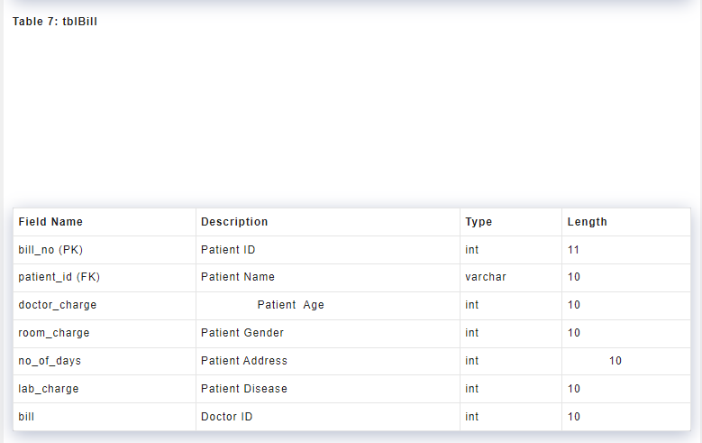

**Website Interface**

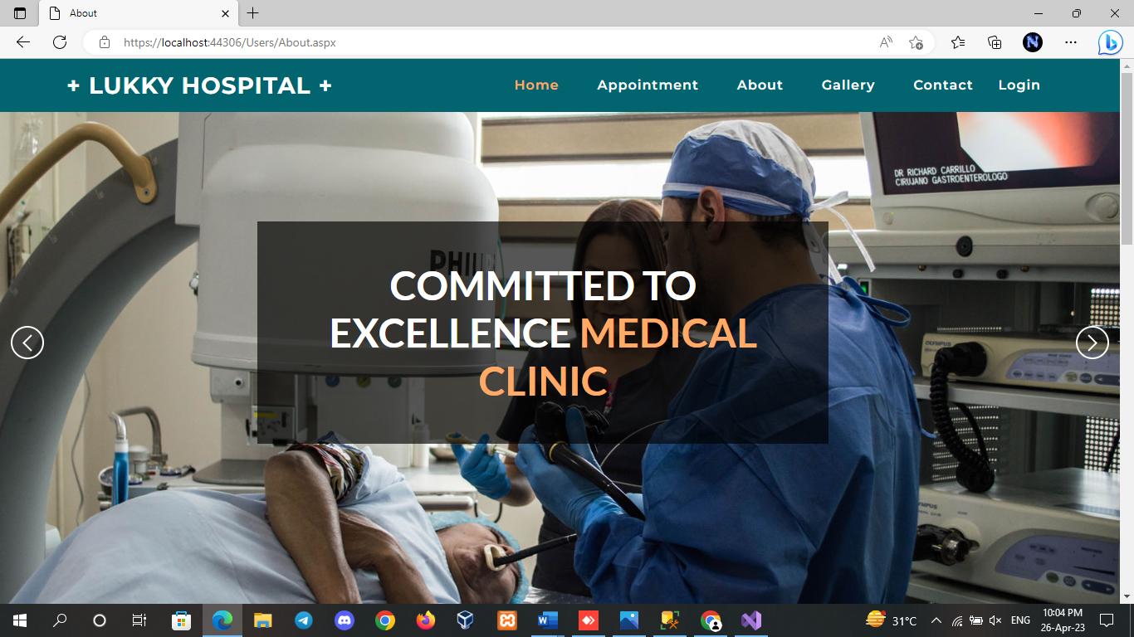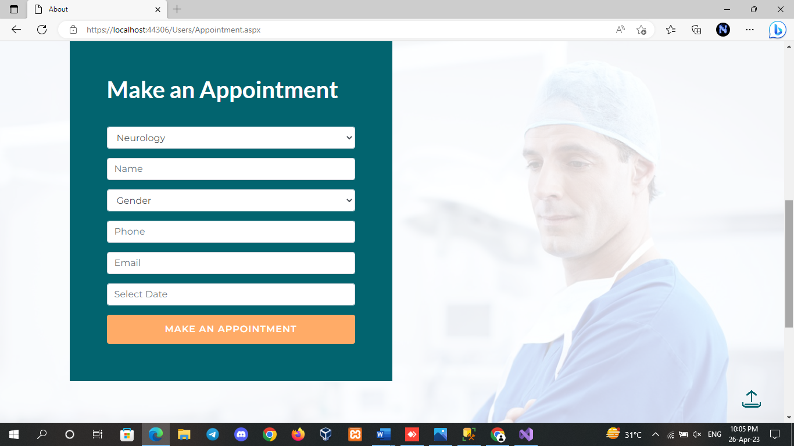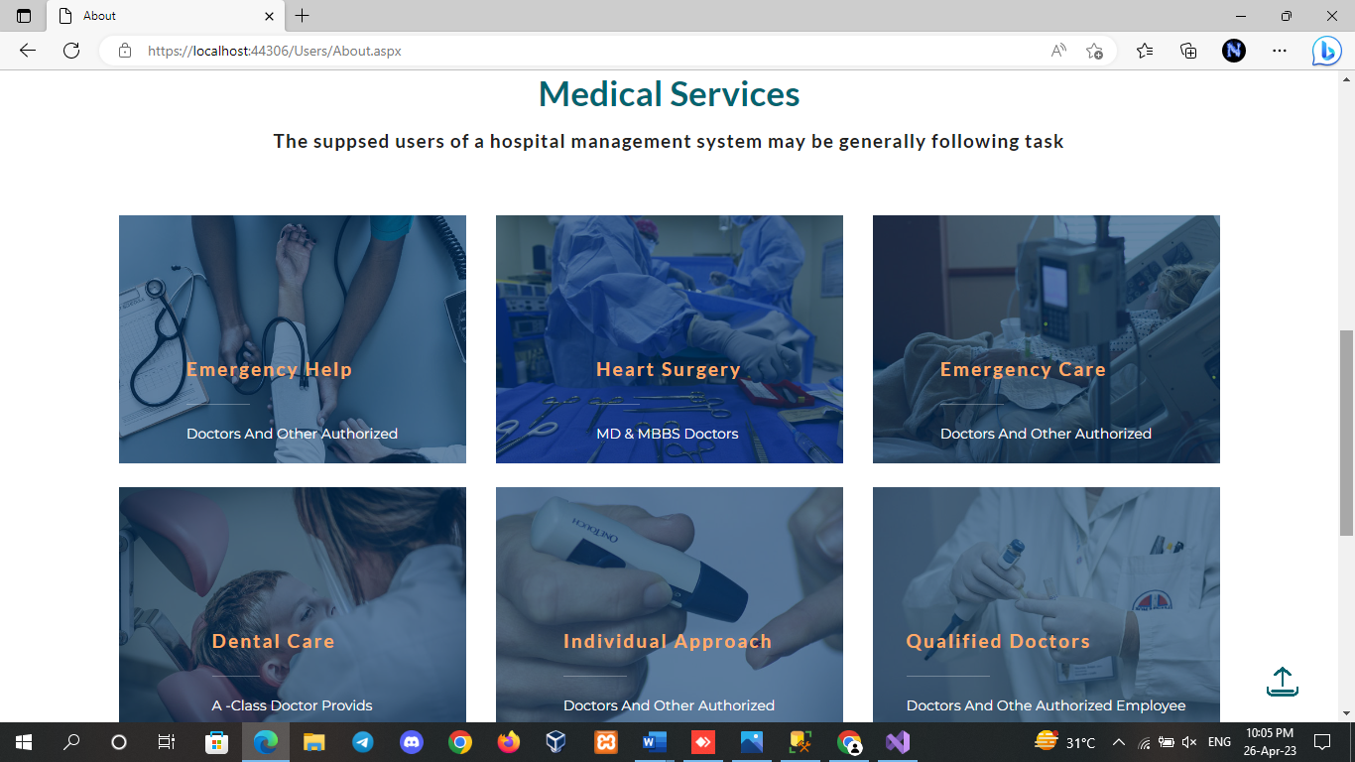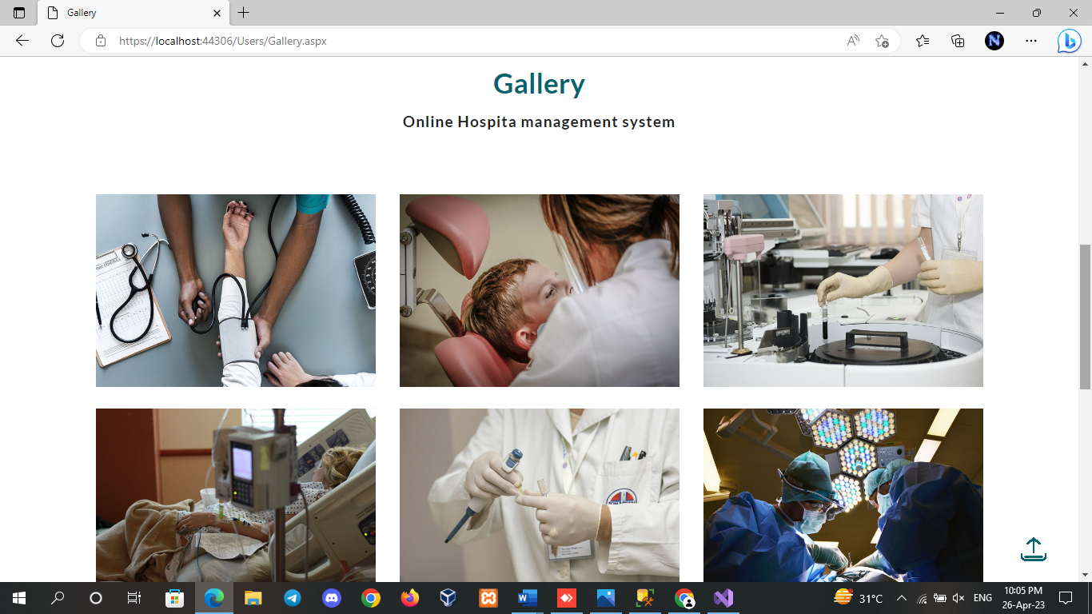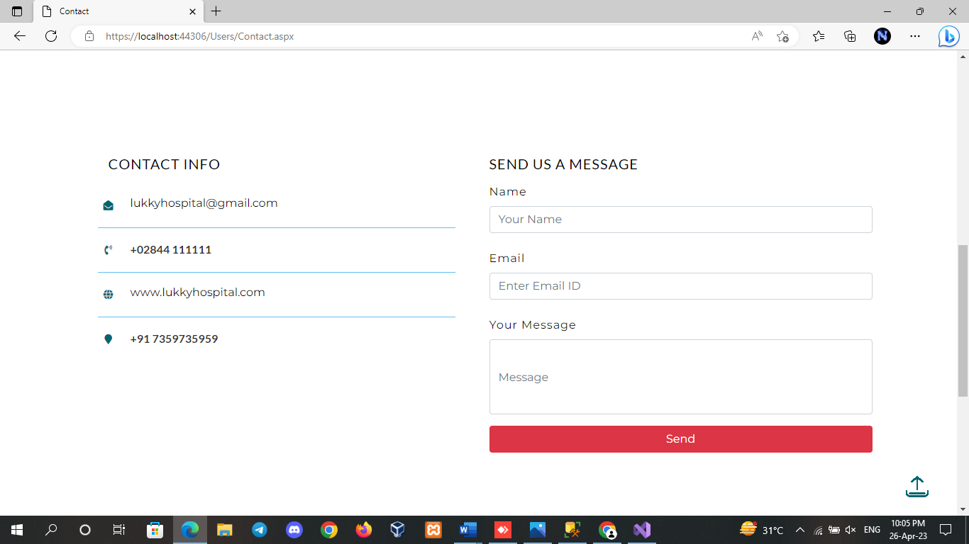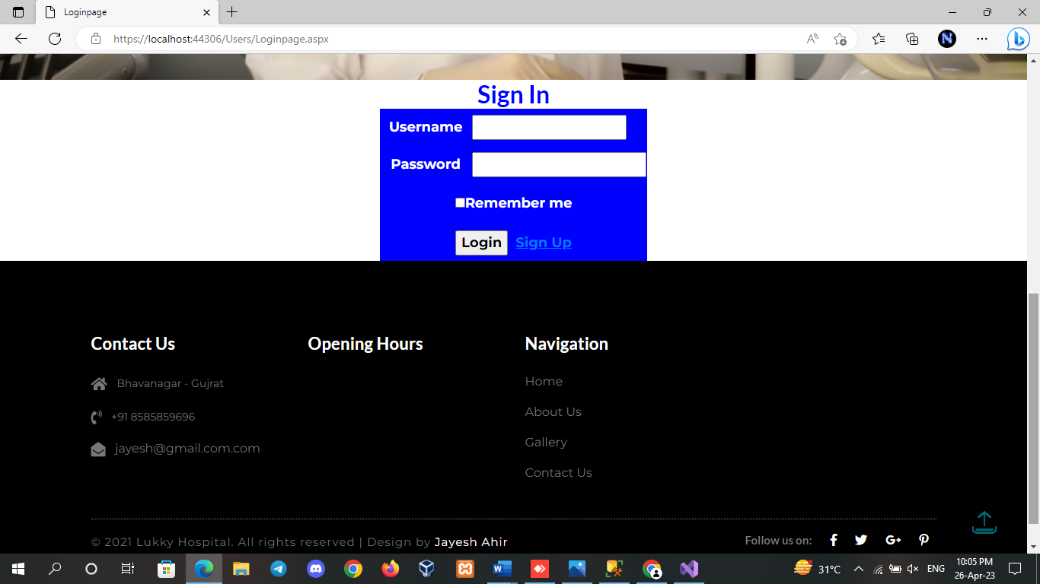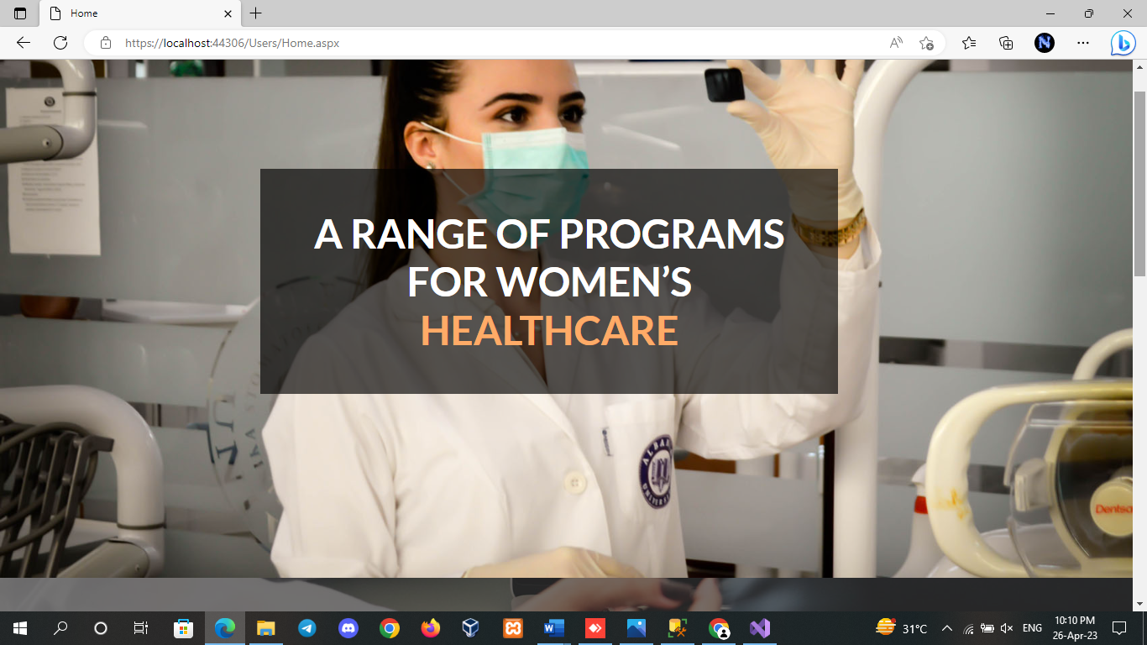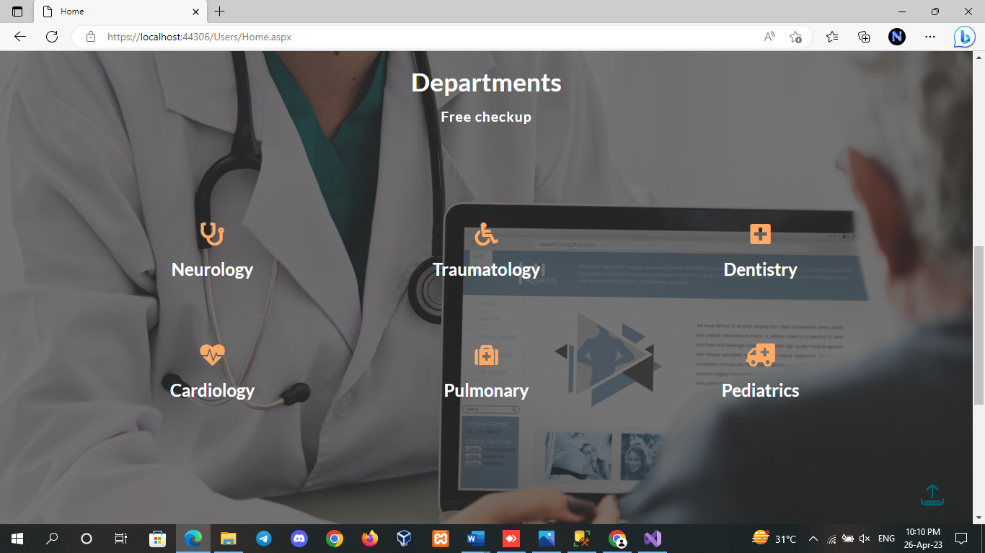

# Development

# Coding Standards

* **Coding Style**
* The following should be kept in mind to maintain a coding style. Such are, Layout, Format, Indentation, organizing code meaningfully, code must be readable and consistent which makes it easy to understand and maintain further.
* **Formatting**
* Always use comments for description.
* Always use curly braces {and} in conditional statements.

Example:

if (condition)

{

// comment

}

* Order declarations within type groups based upon access modifier and their accessibility.
* Public
* Protected
* Internal
* Private
* **Commenting**
* All comments should be written in U.S. English.
* Use # or “””…””” but do NOT use /* */.

# Client Side Validation

Client-side validation in a dental management system website refers to the process of validating user input on the client-side (i.e., in the user's web browser) before the form is submitted to the server. This is done to provide immediate feedback to the user and to prevent invalid data from being submitted to the server.

1. Required fields: Fields that are required for the form to be submitted should be marked as such, and the user should be prompted to fill them out if they are left blank. This can be done by displaying an error message next to the field or by highlighting the field in red.

2. Field format: Fields that require a specific format (e.g., phone numbers, email addresses) should be validated to ensure that the data entered matches the expected format. This can be done using regular expressions or other validation techniques.

3. Field length: Fields that have a maximum length should be validated to ensure that the data entered does not exceed the maximum length. This can be done using JavaScript to count the number of characters entered in the field.

4. Data range: Fields that require a certain range of values (e.g., date of birth, room occupancy) should be validated to ensure that the data entered falls within the expected range. This can be done using JavaScript to check the values entered against the expected range.

5. Password validation: Fields that require a password should be validated to ensure that the password meets certain criteria (e.g., minimum length, use of special characters). This can be done using regular expressions or other validation techniques.

# PROPOSED ENHANCEMENTS

#### Here are some proposed enhancements for a dental management system:

#### 1. Integration with Digital Imaging Software: A dental management system can be enhanced by integrating it with digital imaging software to provide dentists with a comprehensive view of a patient's dental health. This can help in improving diagnosis accuracy and treatment planning.

#### 2. Patient Portal: A patient portal can be added to the dental management system to allow patients to access their dental records, appointment history, and treatment plans online. This can improve patient engagement and satisfaction by providing them with greater control over their dental care.

#### 3. Automated Appointment Reminders: An automated appointment reminder feature can be added to the dental management system to help reduce missed appointments and improve patient communication. This can help in reducing the workload of the front desk staff.

#### 4. Billing and Insurance Management: Enhancing the dental management system to include billing and insurance management features can help in simplifying the billing process and reduce errors. This can improve the efficiency of the billing process and reduce the workload of the administrative staff.

#### 5. Reporting and Analytics: Adding reporting and analytics capabilities to the dental management system can help in tracking key performance indicators and identifying areas for improvement. This can help in improving the overall efficiency and profitability of the dental practice.

CONCLUSION

In conclusion, the dental clinic management system website project is a vital tool for managing and organizing the operations of a dental clinic. It offers an effective way to manage patient records, appointments, treatments, and billing, among other tasks. The website's user-friendly interface, efficient data management, and secure data storage make it a valuable asset for any dental clinic.

By using this system, dental clinics can streamline their operations, reduce paperwork, and improve patient satisfaction. The system's automation capabilities also allow staff to focus more on delivering quality patient care, resulting in better patient outcomes.

Overall, the dental clinic management system website project is an excellent investment for any dental clinic looking to improve its operations, enhance patient care, and increase its bottom line.

BIBLIOGRAPHY

Bibliography on dental management systems:

(https://www.grandviewresearch.com/industry-analysis/dental-practice-management-software-market)

(https://www.dentistryiq.com/practice-management/software/article/16367720/10-dental-practice-management-software-solutions-you-should-consider)

(https://www.softwareadvice.com/resources/what-is-dental-practice-management-software/)

(https://www.pattersondental.com/education/blog/the-benefits-of-dental-practice-management-software)

(https://www.henryscheinone.com/resource-center/education/dental-practice-management-software-what-you-need-to-know/)

These sources can provide valuable information on dental management systems, including their features, benefits, and the latest market trends.